IFG Explore 2nd Year

Term Three - Weeks Four, Five and Six The Rainbow Spiritual
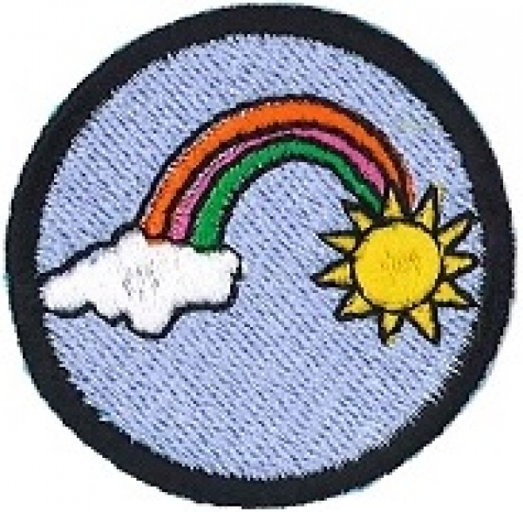
Aim:
To share with the girls God’s very special promise symbolised by the rainbow

Objectives:
- To share what the rainbow is a symbol of
- To enjoy activities relating to the rainbow and its many colours

SetUp:
Commence the formal part of each week with roll call etc.

Devotions:
As these three weeks form a “Spiritual” component of the year’s programme, there are no separate devotions as such. Each week’s programme will have a “Rainbow” focus.

Week One
God made a covenant (an agreement) with Noah and his sons in Genesis Chapter 9 verses 8 – 17. You may choose to share this story from a Bible, a Children’s Bible Stories Book or out of your head.
Ask the girls to share their experiences of seeing a rainbow.

Week Two
Go back to Genesis Chapter 6 and share the happenings that took place leading up to the covenant of the Rainbow.

Week Three
“You will find a pot of gold at the end of a rainbow”. Explain what this means. As you move towards a rainbow the rainbow appears to move further away. So even if there was a pot of gold at the end of the rainbow it is a place that is impossible to reach. This myth is well known in Ireland folklore, where it is said that the pot of gold is guarded by a leprechaun.

In modern terms perhaps the pot of gold at the end of the rainbow is a bit like buying Lotto tickets.

Prayer:
Finish each teaching session with prayer.

Activity Session:
Each week play 2 – 3 games then choose one or more of the suggested activities or feel free to some from your own portfolio.

- Use the three weeks as music intensive with rainbow/ colours songs. Some suggestions are:

Somewhere Over the Rainbow
I Can Sing a Rainbow
The Rainbow Connection
Apple Red Happiness http://www.youtube.com/watch?v=Rf-SfzW4xFU&feature=related

You should be able to freely use published songs within your programme as you should be covered under your Church’s CCL Number.

- Girls to each make a Noah’s Ark using a shoe box and the measurements found in the Bible. As the Ark only had to float on the water and not “go” anywhere it did not need to have a pointy bow and so it was shaped just like a shoe box.
- If you didn’t get to do all of the activities in The Nature’s Colours programme here is another opportunity to use them here
- The 1960’s movie “Pollyanna” starring Hayley Mills has a scene where Pollyanna took apart a crystal lamp and strung the prisms across the window to catch the sunlight thus causing the colours of the rainbow to dance across the wall. Perhaps you could hire the movie from your local video shop or it is available from www.mightyape.co.nz for $14.99. The girls could have a movie afternoon or you could just show that scene. Alternatively purchase a prism from a science supply store and demonstrate the colours.
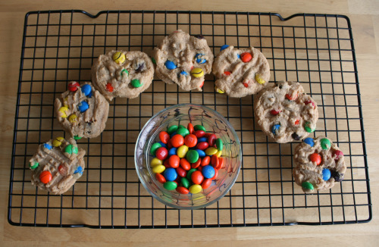
- Crafts:
Rainbow Cookies Use a packet of cake mix, and add in 1 ½ cups of M&Ms for the burst of color. You could make these with any basic chocolate chip cookie recipe, just omit the chocolate chips and add in the M&Ms.

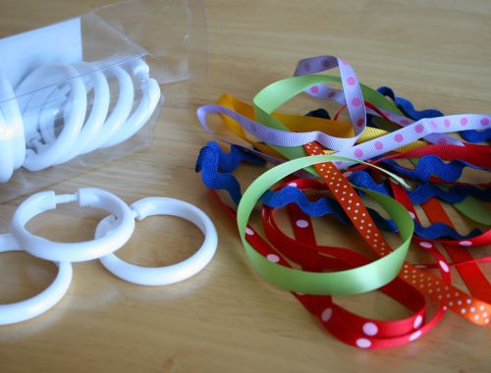
Rainbow Ribbon Rings.
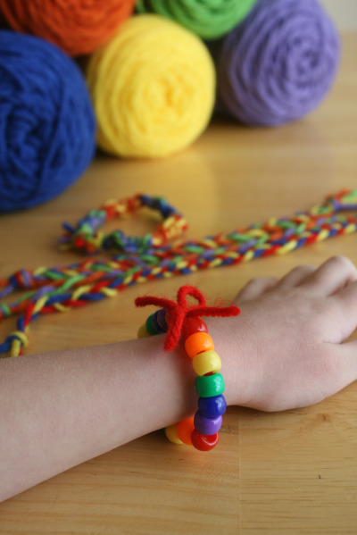
Use shower curtain rings and scraps of ribbon, representing all colors of the rainbow. Tie ribbons to the rings. Dance around and have fun.

Rainbow Friendship Bracelets
A simple craft made by threading different coloured beads on to a piece of wool.

Notices, Closing Prayer and Home Time

